**St. Francis Home Opportunity Drawings**

**6 FOR $ 5.00 or 12 for $ 10.00**

**Drawing on Dec. 20, 2023**

On **November 10, 2018** 10:00 - 3:00

**\* You do not need to be present to win.**

|  |  |
| --- | --- |
|  |  |



15 Gift Baskets

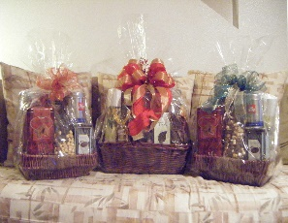

[This Photo](https://www.flickr.com/photos/isleconcierge/3510460521/) by Unknown Author is licensed under [CC BY-NC-ND](https://creativecommons.org/licenses/by-nc-nd/3.0/)

|  |  |
| --- | --- |
| **Name _______________________**  **Phone ______________________**  **Email _________________________** | **Name _______________________**  **Phone _______________________**  **Email _________________________** |
| **Name _______________________**  **Phone ______________________**  **Email _________________________** | **Name _______________________**  **Phone _______________________**  **Email _________________________** |
| **Name _______________________**  **Phone ______________________________**  **Email _________________________** | **Name _______________________**  **Phone ______________________________**  **Email _________________________** |
| **Name _______________________**  **Phone ______________________________**  **Email _________________________** | **Name _______________________**  **Phone ______________________________**  **Email _________________________** |
| **Name _______________________**  **Phone ______________________________**  **Email _________________________** | **Name _______________________**  **Phone ______________________________**  **Email _________________________** |
| **Name _______________________**  **Email ______________________________**  **Phone_____________________________** | **Name _______________________**  **Phone______________________________**  **Email ______________________________** |